**Project Initialization and Planning Phase**

| Date | 5 May 2024 |
| --- | --- |
| Team ID | 737906 |
| Project Name | Walmart Sales Analysis for Retail Industry with Machine Learning |
| Maximum Marks | 3 Marks |

**Problem Statement (Customer Problem Statement):**

Walmart department store customers encounter challenges related to inconsistent product availability, especially during holidays and seasonal shifts. These issues arise from inaccurate sales forecasts influenced by factors such as store size, temperature variations, dates, and holiday patterns. Developing a robust predictive model that considers these variables will enable Walmart to better anticipate customer demand, ensuring shelves are adequately stocked with the right products at the right times, thereby improving the overall shopping experience for customers.

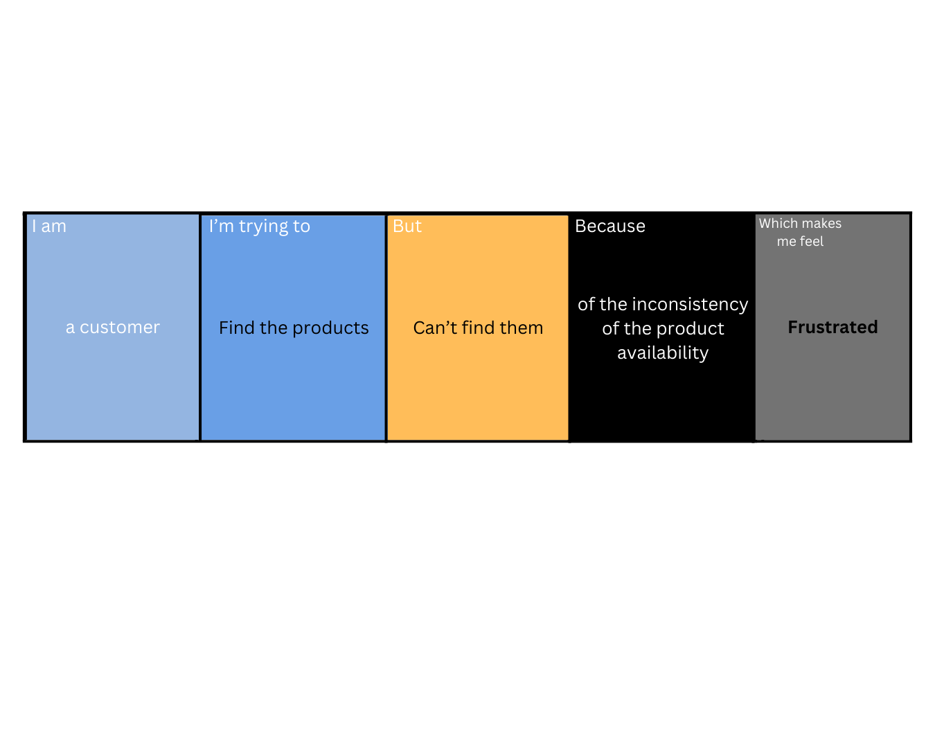



|  |  |  |  |  |  |
| --- | --- | --- | --- | --- | --- |
| **Problem**  **Statement (PS)** | **I am** | **I’m trying to** | **But** | **Because** | **Which makes me feel** |
| PS-1 | A customer | Find the products | Can’t find them | Of the inconsistency of the product availability | Frustrated |